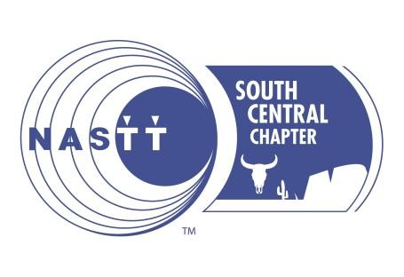
NORTH AMERICAN SOCIETY FOR TRENCHLESS TECHNOLOGY SOUTH CENTRAL CHAPTER
2023 SCHOLARSHIP APPLICATION

DESCRIPTION
- Founded in 1990, NASTT is an industry society of individuals, public organizations and private companies with strong beliefs in the practice, social and environmental benefits of trenchless technology. It represents more than 2,000 members throughout the USA, Mexico and Canada who promote better and more responsible ways to manage our underground infrastructure.
- The NASTT South Central Chapter includes Texas and Oklahoma.
- The South Central Chapter is offering the following scholarships:
  - Undergraduate or Graduate Students - 8 Scholarships in the amount of $1,000 each
- The recipients will be awarded at the NASTT South Central Chapter Event on Tuesday, September 26th , 2023.
- Completed applications must be submitted to cpitzer@thompsonpipegroup.com
- The South Central Scholarship will not affect any national NASTT scholarship
opportunity.

ELGIBILITY
Applications will be accepted from students who meet the following criteria:
- Applicant must be a child, grandchild, or sibling of an active NASTT member, a NASTT student member, or an employee of an active NASTT member organization and resides in the state of Texas, Oklahoma, or Louisiana.
- Students must attend a four-year college, community college, technical or vocational school within the state of Texas or Oklahoma. Students attending Louisiana Tech are also eligible. Applicant must be an undergraduate or graduate student. Preference will be given to those in the fields of construction, engineering, and fields generally related to trenchless construction.
- Applications must include an official transcript.
- Applicants must provide a one page (450 to 500-word) essay on trenchless technology.
- Students are eligible to win the scholarship a total of two times.

ESSAY GUIDELINES
In 500-words or less, please provide an essay based on your choice of one the following four topics listed below. Essays will be graded on originality, clarity of comments, supporting statements, grammar, spelling and overall impression. The completed essay must be submitted with your application. Please attach essay to this application.
- Describe how underground construction and/or trenchless technology interests you as a prospective career choice.
- Describe your impression of the value and the future of the trenchless technology industry.
- Explain how the underground construction industry has helped your community.
- Describe how this scholarship would help you achieve your career goals.

SELECTION PROCESS
Applications must be 100% complete to be considered. Completed applications will be reviewed by the NASTT South Central Chapter board members. Selections will be based on academic achievement, demonstrated leadership, honors achieved, work experience, goals/aspirations, and interest stated in the underground construction industry.
- Completed applications must be received by 11:59 p.m. on September 14th, 2023.
- Complete applications must be submitted to cpitzer@thompsonpipegroup.com
- Scholarship award presentation will take place at our annual NASTT South Central Chapter event in San Antonio, Texas on September 26th, 2023.
- Scholarship winners will be selected based on the following criteria.
  - US, Mexican and Canadian citizens have priority of scholarship selection
  - Students who have interned within the trenchless industry will have priority

SCHOLARSHIP APPLICATION – PLEASE COMPLETE THE FOLLOWING:

First Name: Last Name:

Address:

City: State: Zip:

Email Address:

Phone Number:

Current School:

Classification: Major: GPA:

Do you reside in the states of Texas, Oklahoma or Louisiana? Yes No

Are you a child, grandchild, or sibling of an active NASTT member, or an employee of an active NASTT member organization? Yes No
Your relation to NASTT member:

Name of active NASTT member:

Are you a current member of a NASTT Student Chapter? Yes No

If yes, list the chapter name:

Are you an American, Mexican or Canadian citizen?

Do you consent to publication usage of your photograph by NASTT? Yes No

If selected, are you able to attend the scholarship award presentation which will take place at the NASTT South Central Chapter annual event on September 26, 2023 in San Antonio, Texas? (not a requirement for scholarship selection) _____Yes_____No

NASTT SCHOLARSHIP AWARD CHECK LIST
Completed applications must consist of the following items:
- Scholarship Application Form Complete
- Photograph (Head & Shoulders Style, high-resolution JPEG image)
- Official Educational Institution Transcript (PDF Copy)
- Is your essay of no more than 450 to 500 words attached?

